What You Need to Know to Establish an
Interest Group

Interest Groups are long-term initiatives within the RDA. Interest Groups may do one or more of the following:

- Serve as a platform that leads to the formation of one or more Working Groups. An existing Interest Group may refine their ideas into implementable actions by creating focused Case Statements to create one or more Working Groups. The process of establishing a Working Group is described in the “Setting up a Working Group” section below.

- Support communication and coordination among a cluster of related Working Groups/Interest Groups that may be grouped by theme (e.g., research domain, data publishing, data life cycle component, etc.)

- Enable better communication and coordination across different Working Groups/Interest Groups (e.g, all domain-specific groups, all education groups, between technically oriented and domain-specific groups, etc.)

- Serve to communicate and coordinate with a specific community outside RDA, fostering synergies, bringing new groups/members to RDA and conversely bringing the WGs activities to the attention of external parties.

Please read through the next few pages, and complete the template at the end to begin.

Need additional help or guidance? Have other questions? Contact enquiries@rd-alliance.org.

Interest Group Charter Review Process
What to Expect

Interest Groups undergo a formal review (see Figure 1) before they are recognized and endorsed by RDA.

Step 1. One or more interested members write up a Draft Charter using the RDA Interest Group Draft Charter Template (see below), and send the completed draft to the RDA Secretariat at enquiries@rd-alliance.org. While writing your Draft Charter, please keep the following elements in mind:

- There should be 2-4 co-chairs leading the initiative – this helps to keep the group going and balance workload.
- There should be a balance of expertise and geographic representation - members are international experts, and ideally the group spans at least 3 continents
- The proposed IG should provide a platform for communication and coordination around the topic of interest
- The group should be technology and product neutral – it shouldn’t promote one specific product or technology
- There should be no, or extremely minimal, overlap with existing IGs / WGs

Step 2. The Secretariat puts the Draft Charter out for Community Review. During the Community Review phase (4 weeks), all members of the RDA community are invited to read and comment on any aspects of the document.

Step 3. If any comments are received, the IG writing team addresses them and provides the revised Draft to the Secretariat. (1 week at most)

Step 4. The Draft (revised or original) then goes to TAB for review. During the TAB Review phase (2 weeks), 2 members of the TAB volunteer to review the Draft Charter according to the following criteria:

Focus and Fit:
Are the Interest Group objectives aligned with the RDA mission? Is the scope too large for effective progress, too small for an RDA effort, or not appropriate for the RDA? Overall, is this a worthwhile effort for the RDA to take on? Is this an effort that adds value over and above what is currently being done within the community?

Capacity:
Does the initial membership list include sufficient expertise, and disciplinary and international representation? Are the people involved in the Interest Group sufficient to make tangible progress? What individuals or organizations are missing?

Impact and Engagement:
Is it likely that the Interest Group will engage the intended community? Is there evidence that the research community wants this? Will the outcome(s) of the Interest Group foster data sharing and/or exchange?

The TAB reviewers will come to one of three conclusions, providing appropriate supporting material: the Charter is sufficient, requires revision, or is rejected. Depending upon the conclusion, another revision of the Draft Charter may be in order. This cycle may need to be repeated until TAB is satisfied with the content.

Step 5. Council then reviews the Draft Charter in consultation with TAB (2 weeks), and makes one of four possible decisions:

- Recognized and endorsed as is: Strong Charter. Group is recognized as an RDA IG and should commence its work.
- Recognized and endorsed subject to specific revisions: Worthwhile idea, changes need to be made to strengthen the Charter and meet approval criteria. After the approach has been modified, the group will be recognized by RDA and commence its work.
- Encouraged but not presently endorsed: Good idea but needs refinement. The group needs to mature its concept and refine its Charter for approval. Council and/or TAB will provide specific feedback and clarification on what is needed.
- Not endorsed: The idea is not a good fit for the RDA or does not meet other criteria for approval. Council will provide specific feedback and clarification.

Step 6. Once again, any revisions required must be completed, and the cycle repeated until Council is satisfied with the content.

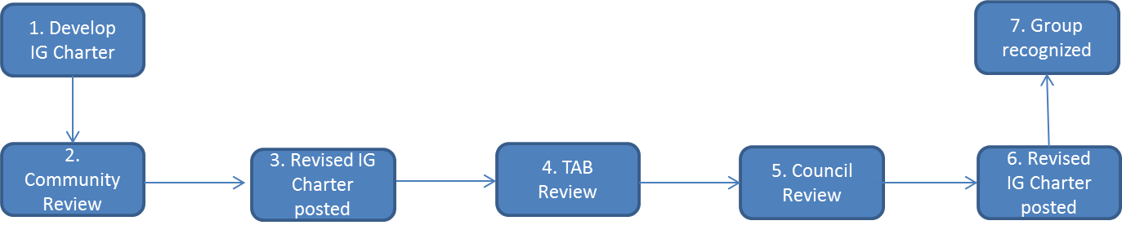
Step 7. Upon approval, Secretariat will help the IG with its working, communication, and recording processes. Joint activities with RDA affiliates are encouraged.

Figure 1. Interest Group Draft Charter Review Process.

RDA Interest Group Draft Charter Template

Name of Proposed Interest Group:

Introduction (A brief articulation of what issues the IG will address, how this IG is aligned with the RDA mission, and how this IG would be a value-added contribution to the RDA community):

User scenario(s) or use case(s) the IG wishes to address (what triggered the desire for this IG in the first place):

Objectives (A specific set of focus areas for discussion, including use cases that pointed to the need for the IG in the first place. Articulate how this group is different from other current activities inside or outside of RDA.):

Participation (Address which communities will be involved, what skills or knowledge should they have, and how will you engage these communities. Also address how this group proposes to coordinate its activity with relevant related groups.):

Outcomes (Discuss what the IG intends to accomplish. Include examples of WG topics or supporting IG-level outputs that might lead to WGs later on.):

Mechanism (Describe how often your group will meet and how will you maintain momentum between Plenaries.):

Timeline (Describe draft milestones and goals for the first 12 months):

Potential Group Members (Include proposed chairs/initial leadership and all members who have expressed interest):

FIRST NAME | LAST NAME | EMAIL | TITLE
Add more lines as needed by hitting the ‘tab’ key at the very end of the ‘Title’ line.

