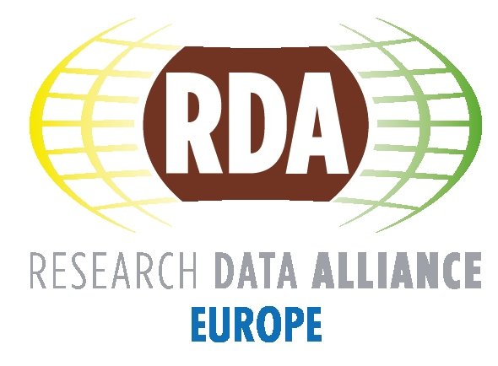 | Task Force on Sustainability
  - Draft Terms of Reference
  - Fotis Karayannis, v1.5 - 31.03.2017

Background
During the first RDA-Europe 3.0 informal review, the reviewers came up with a set of recommendations, the first of which was about the RDA Europe perspective on RDA sustainability.
The formulation of the recommendation was that “RDA Europe 3 should develop short-term (2 to 5 years) and longer-term sustainability goals that will make RDA a centerpiece of European strategy for open science”.
The rational and the main actions are described below:
- Rationale: As data-intensive research continues to expand in scale across disciplines and countries, knowledge infrastructures must expand in scale and sophistication to keep Europe competitive.
- RDA efforts will continue to be valuable for all research communities. RDA Europe 3 members are in the best position to design a sustainability plan.
- The financial situation of RDA is currently complex to assess. Establishing a comprehensive budget for RDA global and RDA Europe is now necessary.

Objective
The main objectives of the Task Force are
- to contribute to RDA Global sustainability from the RDA Europe perspective, containing provisions for governance, funding and fiscal policies.
- to determine the place of RDA in the European infrastructure and data landscape
The sustainability plan will include the following components:
- Analysing the overall context and the e-Infrastructures/data landscape in which RDA and RDA Europe are operating, including possible gaps. This will assess among others the relations of RDA Europe with:
  - RDA Global
  - RDA national/regional entities/partners
  - the emerging data infrastructure eco-system in Europe
- Assessing the status of RDA sustainability from the RDA Europe perspective in terms of:
  - Funding-Financing: Establishing a budget plan for RDA Global and RDA Europe
  - Governance structures and processes including the RDA Foundation
  - Fiscal processes and policies, including the RDA Foundation
- Propose a set of recommendations for the future (on the above) to be taken up by the following phases of RDA Europe.

Output and Target Audiences
The Task Force will prepare a concise sustainability plan covering the above 3 points, i.e. coming up with a short landscape analysis (1) and then focusing on assessment of the current state of RDA from the RDA Europe perspective (2), along with a set of recommendations for the future (3).
The document will mainly be targeted to the following main stakeholders, so that they can be assisted in their related actions:
- Funding agencies policy and decision makers.
  - RDA Europe funders, namely the European Commission and national funders
  - RDA Council and related RDA Council Subcommittees including the one on Sustainability and Funding
  - The RDA Funders Forum, and in particular the funding agencies contributing to the RDA Global budget
- Other relevant stakeholders
  - RDA Europe 3 and RDA Europe 4 project partners, and other stakeholders involved in the next RDA Europe phases.
The goal within RDA EU 3 is to write a concise document containing major assertions and not a comprehensive document. As the document will contain budgeting / funding information, it may not be a public document, however it will be considered whether a public version will be created removing sensitive information.

Ownership, Membership and Links
The Task Force primarily reports to the RDA Europe Board of Directors (BoD) and the project director, Peter Wittenburg. The BoD has appointed Fotis Karayannis (RDA Secretariat, ATHENA Research Centre) as the Chair of the Task Force, while members of the Task Force (who either volunteered or were invited) include Peter Wittenburg (RDA Europe 3 coordinator), Mark Parsons (RDA Secretary General), Hilary Hanahoe (RDA Europe 3 partner and RDA Europe 4 coordinator) and Sandra Collins, Fabrizio Gagliardi, Leif Laaksonen and Raphael Ritz (RDA Europe 3 partners). ATHENA Research Center will receive 3 additional Person Months and 10.000 Euros of travel funding. ATHENA Research Center will organise the meetings and prepare their minutes, and act as the editor of the output document. The role of the Task Force members is to provide guidance and feedback.
The Task Force will liaise with the RDA Secretary General and above target stakeholders for feedback and in particular with the relevant RDA Global Council Subcommittees:
- Sustainability and Funding (where Fotis Karayannis is also the RDA Secretariat liaison)
- Finance
The Task Force will use and refine the existing work from the above subcommittees, in particular the work on the RDA Global budgeting and business plan.

Duration and Milestones
The overall duration of the Task Force spans from February 2017 to around February 2018, when RDA Europe 3.0 is expected to close, and depending also on the starting date of the RDA Europe 4.0 project. The Task Force will try to use the RDA Plenaries to present its work progress to relevant stakeholders, depending on its progress. First major focus dimensions will be presented at the formal review in the beginning of May. A first draft of the Task Force output will be ready by the end of July 2017, while the final document will be delivered with the closing of the Task Force.

Communication and Reporting
A dedicated internal RDA Organic Group will be set up to facilitate communications. Also, conference calls and workshops may be held. The Task Force Chair will report the status of this activity to the project at BoD meetings and other major European meetings.

