Research Data Alliance (RDA)
6th Working Group Collaboration Meeting
Dec. 12 - 13, 2016

Meeting Venue

All meetings will be held at:
National Institute of Standards and Technology (NIST)
Administration Building, Lecture Room D
100 Bureau Drive, Building 101, Gaithersburg, MD 20899-1060

NIST Visitor Website: http://www.nist.gov/public_affairs/visitor/

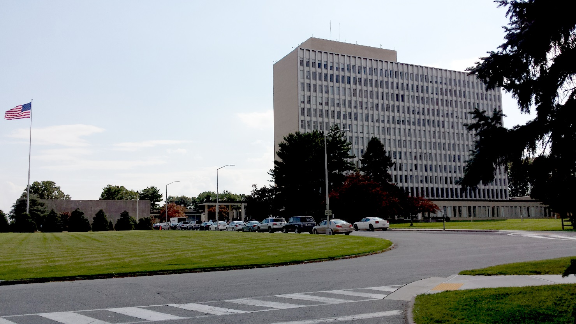
Meeting Host POC

Host: Wo Chang, wchang@nist.gov, (301) 975-3439
Ginger White, ginger.white@nist.gov, (301) 975-4495
Logistics: Mary Lou Norris, marylou.norris@nist.gov, (301) 975-2002
Registration

All attendees must be pre-registered to gain entry to the NIST campus. Photo identification must be presented at the main gate to be admitted to the conference. International attendees are required to present a passport. Attendees must wear their conference badge at all times while on the campus. There is no on-site registration for meetings held at NIST. To register, please go to https://appam.certain.com/profile/form/index.cfm?PKformID=0x32054c1ac

Security Instructions

If you are not registered, you will not be allowed on site. Registered attendees will receive security and campus instructions prior to the workshop.

Effective July 21, 2014, under the REAL ID Act of 2005, federal agencies, including NIST, can only accept a state-issued driver’s license or identification card for access to federal facilities if issued by states that are REAL ID compliant or have an extension. Driver’s licenses from the following states and territories are not compliant with the Real ID Act of 2005 and will not be accepted as identification: Alaska, Arizona, Oklahoma, Louisiana, Massachusetts, Maine, and American Samoa. For more information, please visit this page.

NON U.S. CITIZENS PLEASE NOTE: All foreign national visitors who do not have permanent resident status and who wish to register for the above meeting must supply additional information. Failure to provide this information prior to arrival will result, at a minimum, in significant delays (up to 24 hours) in entering the facility. Authority to gather this information is derived from United States Department of Commerce Department Administrative Order (DAO) number 207-12. When registration is open, the required NIST-1260 form will be available as well.

Directions from local airports

Driving Directions from Washington Dulles International Airport (IAD)
Follow the Dulles Access Road to Bethesda/Baltimore entrance ramp to 495
Take 495 (left lane exit) to 270 North
Take Exit #10 toward Clopper Road (MD 117) and Quince Orchard Rd (MD 124)
At the first light turn right onto West Diamond Ave.
For NIST campus:
At next stop light (Bureau Dr.) turn left

Driving Directions from Baltimore Washington International Airport (BWI)
Take 195 West
Take 95 South Exit #4B toward Washington
Take 495 West Exit #27-25 toward College Park/Silver Spring
Take 270 North Exit #35 toward Frederick
Take 270 Local North toward Montrose Road
Take Exit #10 toward Clopper Road (MD 117) and Quince Orchard Rd (MD 124)
At the first light turn right onto West Diamond Ave.
For NIST campus:
At next stop light (Bureau Dr.) turn left

Driving Directions from Ronald Reagan Washington National Airport
Exit National Airport heading north on the George Washington (GW) Parkway toward Maryland
Take the GW Parkway to 495 North toward Maryland
Take 495 (left lane exit) to 270 North
Direction to NIST campus
Take Exit #10 toward Clopper Road (MD 117) and Quince Orchard Rd (MD 124)
At the first light turn right onto West Diamond Ave.
For NIST campus:
At next stop light (Bureau Dr.) turn left

To locate Administration Building when arriving on campus see map below.

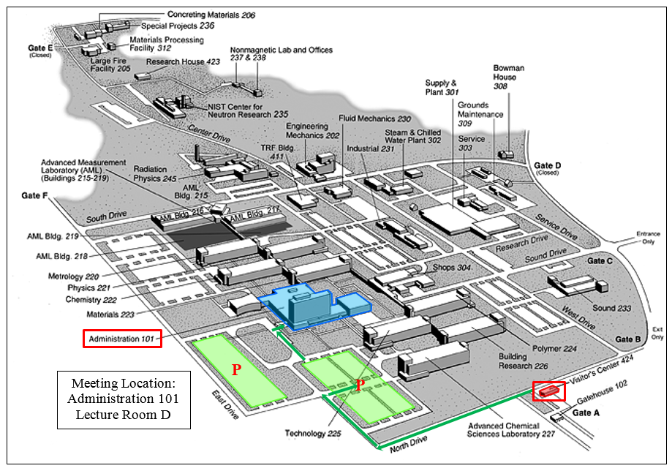

Hotels/Motels - Gaithersburg Area (distance various)

Disclaimer: These commercial establishments have no official relationship with NIST. We provide this information as a convenience to NIST visitors and conference attendees. NIST does not endorse or guarantee the quality or services provided by these establishments.

Best Western Hotel  1251 West Montgomery Ave., Rockville, Md. 20850  (301) 424-4940 Fax: (301) 424-1047 | Holiday Inn Hotels  2 Montgomery Village Ave., Gaithersburg, Md.. 20879  (301) 948-8900 Fax: (301) 258-1940
Comfort Inn Shady Grove  16216 Frederick Road, Gaithersburg, Md. 20877  (301) 330-0023 Fax: (301) 258-1950 | Homestead Studio Suites Hotel  20141 Century Blvd., Germantown, Md. 20874  (301) 515-4500 Fax: (301) 515-4565
Courtyard Gaithersburg Washingtonian Center  204 Boardwalk Place, Gaithersburg, Md. 20878  (301) 527-9000 Fax: (301) 527-9001 | Hyatt House  200 Skidmore Boulevard, Gaithersburg, Md. 20877  (301) 527-6000 Fax: (301) 527-1800
Courtyard by Marriott-Rockville  2500 Research Blvd, Rockville, Md. 20850  (301) 670-6700 Fax: (301) 670-9023 | Motel 6  497 Quince Orchard Road, Gaithersburg, Md. 20878  (301) 977-3311 Fax: (301) 990-1053
Crown Plaza Rockville  3 Research Court, Rockville, Md. 20850  (301) 840-0200 Fax: (301) 2588-0160 | Oakwood Worldwide  9806 Mahogany Drive, Gaithersburg Md. 20878  (877) 969-8953 Fax: (410) 609-2019
Extended Stay America Hotel  12450 Milestone Center Dr., Germantown, Md. 20876  (301) 540-9369 Fax: (301) 540-8753 | Quality Suites Rockville  1380 Piccard Drive, Rockville, Md. 20850  (301) 590-9880 Fax: (301) 590-9614
Extended Stay America Hotel  201 Professional Drive, Gaithersburg, Md. 20879  (301) 963-3539 Fax: (301) 963-2034 | Residence Inn by Marriott-Gaithersburg  9721 Washingtonian Blvd, Gaithersburg, Md. 20878  (301) 590-3003 Fax: (301) 590-2722
The NEW Fairfield Inn & Suites Germantown Gaithersburg  20025 Century Blvd., Germantown, Md. 20874  (301) 916-0750 Fax: (301) 916-0751 | Sheraton Rockville Hotel  920 King Farm Blvd, Rockville, Md. 20850  (240) 912-8200 Fax: (240) 912-8205
Gaithersburg Marriott Washingtonian Center  9751 Washingtonian Blvd., Gaithersburg, Md. 20878  (301) 590-0044 Fax: (301) 212-6155 | SpringHill Suites by Marriott-Gaithersburg  9715 Washingtonian Blvd., Gaithersburg, Md. 20878  (301) 987-0900 Fax: (301) 987-0500
Hampton Inn & Suites Washington, DC North-Gaithersburg  960 N. Frederick Avenue, Gaithersburg, MD 20879  (301) 990-4300 Fax: (301) 990-4301 | Suite America  916 Beacon Square Court, Gaithersburg, Md. 20878  (877) 748-8341 Fax: (301) 468-5707
Hilton Washington DC North/Gaithersburg  620 Perry Parkway, Gaithersburg, Md. 20877  (301) 977-8900 Fax: (301) 869-8597 | TownPlace Suites by Marriott  212 Perry Parkway, Gaithersburg, Md. 20877  (301) 590-2300 Fax: (301) 590-0909
Hilton Washington DC/Rockville  1750 Rockville Pike, Rockville, Md. 20852  (301) 468-1100 Fax: (301) 468-0163 | Wyndham Garden Hotel Gaithersburg  805 Russell Ave., Gaithersburg, Md. 20879  (301) 670-0008 Fax: (301) 948-4538

Climate - Gaithersburg, Maryland forecast courtesy of Weather.com
Disclaimer: These commercial establishments have no official relationship with NIST. We provide this information as a convenience to NIST visitors and conference attendees. NIST does not endorse or guarantee the quality or services provided by these establishments.

Electricity
The voltage in the US is 110V. Two-pin plugs are standard.

